5 **Documentation**

5.1 **Online manual**

For black bodies, Stefan’s law is

E = σ (T4-T04) (1)

Where E is the net amount of radiation emitted per second per unit area by a body at temperature T and surrounded by another body at temperature T0. σ is called Stefan’s constant. A similar relation can also hold for bodies that are not black. In such case, we can write

P = C (Tα -T0α) (2)

Where, P is the total power emitted by a body at temperature T surrounded by another at temperature T0, α is a power quite closed to 4 and C is some constant depending on the material and area of such a body. Further the relation can be put as

P = C Tα (1-T0α/ Tα) (3)

If T>> T0 (e.g., T = 1500K, and T0 ≈ 300K), we can write

P = C Tα (4)

Or

Log10P = αLog10T + Log10C (5)

The graph between Log10P and Log10T should be a straight line whose slope gives α.

**Experimental setup:**

In order to verify Stefan’s law the experimental set up is as shown in Figure 3, with the help of this setup we have to measure the following two parameters:

1. Power radiated P: We use in this experiment tungsten bulb as the radiating body and in the steady state the electrical power V.I should be equal to the radiation power P (neglecting power lost in the leads and through the gas in the bulb).
2. Temperature of the radiating body, T: In our experiment we need measure the temperature of tungsten filament. This is achieved by measuring the resistance of filament, Rt and then using the relation

Rt = R0 (1+ αt + βt2) (6)

With α and β being known for tungsten, we can find temperature of the filament. One serious limitation arises in the measurement of R0 (resistance of filament at 0°C or 273K, one can write R0 or R273). At very small current, V/I ratio will give filament resistance as well as lead resistance. In order to calculate R0 then we measure the resistance (Rg) at the stage when the filament first starts glowing and temperature at this stage is approximately 800K. At this temperature contribution of lead resistance becomes smaller by a factor of 4 as compared with that at 273K. Therefore measurement of Rg (=R800) and using the computed factor, R800/R273, a more accurate value of R273 (=R0) is found.

1. With different increasing and decreasing values of current, we adjust such that the bulb glows each time. Then for value of V and I, ratio V/I is found which gives Rg. This is the filament resistance at 800K. From Rt/R0 vs. T graph, we note that

Rt/R0 = R800/R273 = 3.9 (7)

Therefore, R800/3.9 = R273

Or

Rg/3.9 = R0 (8)

1. Now filament current I is increased from a value below glow stage to values high enough to get dazzling white light, measuring voltage V across bulb every time. From these V and I values, we deduce power P (=VI) and Rt (=V/I). From Rt using the value R0 (or Rg /3.9) or R273K , we deduce the temperature T of the filament and obtain a graph in Log10P against Log10T.
2. Value of temperature for a particular Rt/R0 can be calculated from the linear fit relation

T = 168.04113 + 157.25189 x Rt /Ro (9)

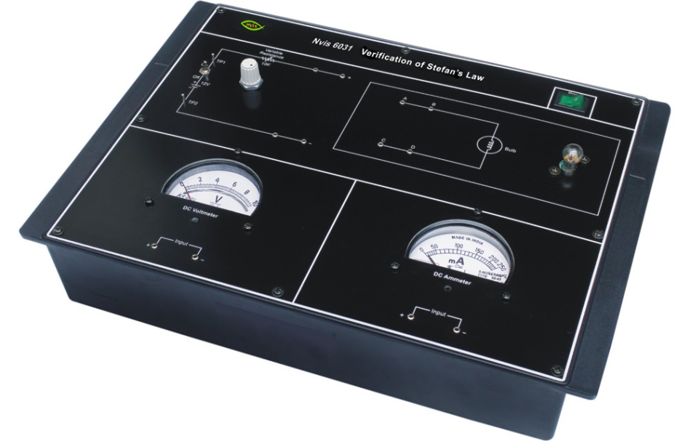

Figure 3: Stefan’s law verification apparatus (http://www.nvistech.com/technical-training/physics/verification-of-stefans-law)

5.2 **Step-by-step procedure**

1. Press the Key ‘K’ ON.
2. Increase the voltage from 0 V with an increase of 0.5 V till 14.5 V.
3. Measure the corresponding current in ammeter.
4. Place the values of current and voltage in Table 1.
5. Decrease the voltage from 15.0 V with a decrease of 0.5 V till 1.0 V.
6. Place these values of current and voltage in Table 1.
7. Calculate mean Rg for each observation and finally value of R0 will be calculated.
8. Take any 15 observations from Table 1 and place them in Table 2
9. Use the value of R0 calculated in Table 1 to calculate Rt/R0 in Table 2.
10. Use fitting Equation (9) to find the temperature corresponding to each value of Rt/R0 .
11. Log P and Log T values will be directly calculated.
12. Use these values of log P and log T to plot a curve.
13. Calculate the slope of the curve which will give the value of α.
14. If α is close to 4 Stefan’s law is proved.

**Observations:**

**Table 1: Readings for determination of the filament resistance (Rg) at temperature T= 800K:**

|  |  |  |  |  |  |  |  |
| --- | --- | --- | --- | --- | --- | --- | --- |
| S.No. | Current Increasing | | | Current Decreasing | | | Mean Rg/3.9 |
| Voltage V volts | Current I amp. | Rg=V/I Ohms | Voltage V volts | Current I amp. | Rg=V/I Ohms |  |
| 1 |  |  |  |  |  |  |  |
| 2 |  |  |  |  |  |  |  |
| 3 |  |  |  |  |  |  |  |
| 4 |  |  |  |  |  |  |  |
| 5 |  |  |  |  |  |  |  |
| 6 |  |  |  |  |  |  |  |
| 7 |  |  |  |  |  |  |  |
| 8 |  |  |  |  |  |  |  |
| 9 |  |  |  |  |  |  |  |
| 10 |  |  |  |  |  |  |  |
| 11 |  |  |  |  |  |  |  |
| 12 |  |  |  |  |  |  |  |
| 13 |  |  |  |  |  |  |  |
| 14 |  |  |  |  |  |  |  |
| 15 |  |  |  |  |  |  |  |
|  | | | | | | | **Mean Ro=** |

**Table 2: Determination of Power P for different temperature T:**

|  |  |  |  |  |  |  |  |  |
| --- | --- | --- | --- | --- | --- | --- | --- | --- |
| **S. No.** | **Voltage V volts** | **Current I amp.** | **Rt=V/I Ohms** | **Rt/Ro** | **Temperature corresponding to Rt/Ro From eq 9.** | **Log10T** | **Power P = V I**  **Volts** | **Log10P** |
| 1 |  |  |  |  |  |  |  |  |
| 2 |  |  |  |  |  |  |  |  |
| 3 |  |  |  |  |  |  |  |  |
| 4 |  |  |  |  |  |  |  |  |
| 5 |  |  |  |  |  |  |  |  |
| 6 |  |  |  |  |  |  |  |  |
| 7 |  |  |  |  |  |  |  |  |
| 8 |  |  |  |  |  |  |  |  |
| 9 |  |  |  |  |  |  |  |  |
| 10 |  |  |  |  |  |  |  |  |
| 11 |  |  |  |  |  |  |  |  |
| 12 |  |  |  |  |  |  |  |  |
| 13 |  |  |  |  |  |  |  |  |
| 14 |  |  |  |  |  |  |  |  |
| 15 |  |  |  |  |  |  |  |  |

**Result:**

Plot the graph as log10P vs. log10T will be straight line.

**Calculations:**

Slope of the straight line log10P vs. log10T gives the value of α.

5.3 **Quiz for Self-evaluation**

1. Stefan’s law is related with:

a) Conduction b) convection c) radiation d) none of these

2. In Stefan’s law the power raised to the absolute temperature of the body is:

a) 2 b) 3 c) 4 d) 5

3 The plot of Log P Vs log T for anybody is:

a) Straight line b) parabolic c) hyperbolic d) elliptical

4. Absorptivity of the perfectly black body is:

a) 1 b) 0.5 c) 2 d)4

5. Resistance of any conductor _______________ with increase in temperature.

a) Increases b) decreases c) remains constant d) none of these

5.4 Related resources

1. <https://www.scribd.com/document/70070454/Stefan-s-Law>
2. <http://studenti.fisica.unifi.it/~carla/varie/Stefan-Boltzmann_law_in_a_light_bulb.pdf>
3. <http://www.physics.ryerson.ca/sites/default/files/PCS213-StefanBoltzmannFinal.pdf>